Bayes’ Theorem in Naive Bayes Algorithms

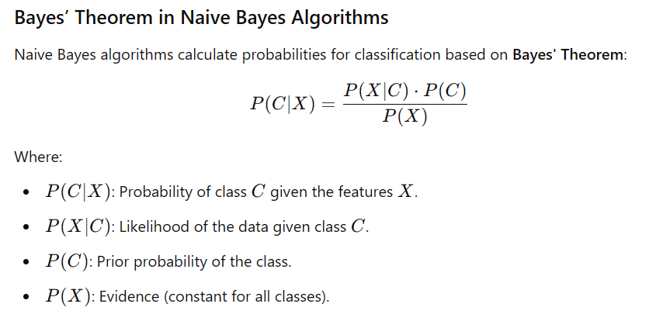

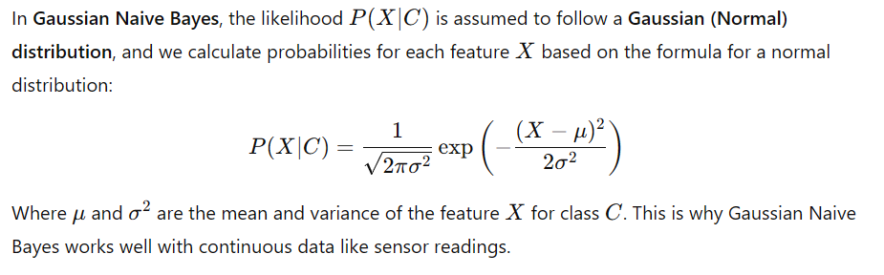

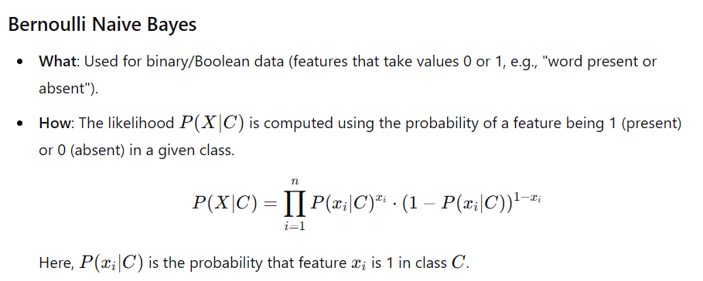

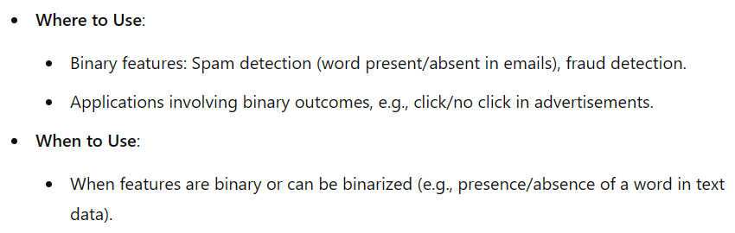

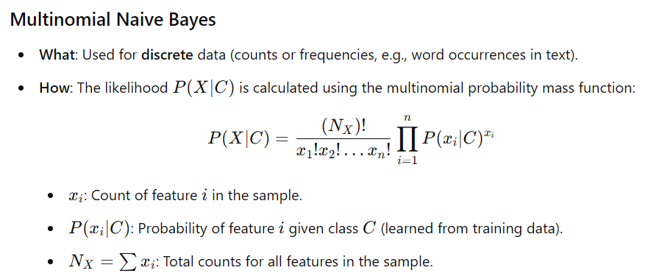
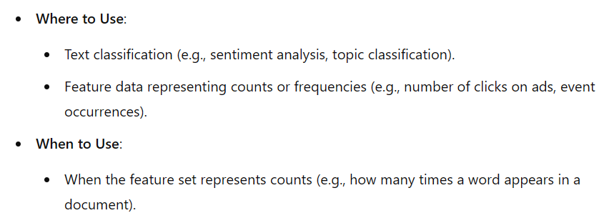
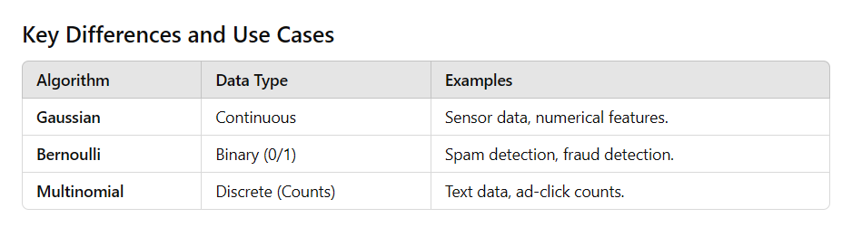

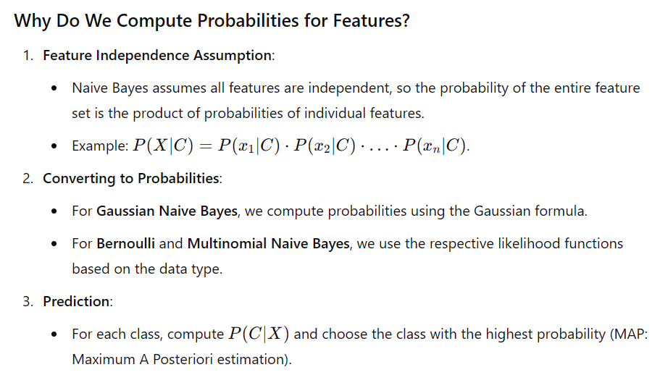

1. What is Naive Bayes?
Naive Bayes is a supervised machine learning algorithm used for classification tasks. It is based on Bayes' Theorem, which calculates probabilities to determine the most likely class for a given input.
- Type: Supervised Learning
- Task: Classification
- Common Use Cases:
  - Text Classification: Spam detection, sentiment analysis, topic modeling.
  - Medical Diagnosis: Predict diseases based on symptoms.
  - Risk Assessment: Fraud detection.

2. Why is it Called "Naive"?
The algorithm makes a "naive" assumption:
- All features are independent: It assumes the value of one feature doesn’t affect the value of another.
- Example: For spam detection, the presence of the words "win" and "money" are treated as independent, even though they often occur together in spam.
In reality, features are often correlated, but the algorithm works surprisingly well despite this simplification.

3. How Does Naive Bayes Work?
Imagine you're sorting emails into "Spam" or "Not Spam" categories.

Step-by-Step:
- Learn From Data:
  - From labeled emails, calculate:
    - Prior probabilities: How often each class occurs (e.g., P(Spam), P(Not Spam)).
    - Likelihood probabilities: How often each word (feature) appears in spam and non-spam emails (e.g., P("win"|Spam)).

- Calculate Probabilities for New Data:

- For a new email, calculate the posterior probability for each class using Bayes' Theorem
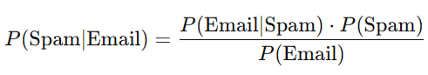
- Repeat for "Not Spam".

3. Choose the Most Likely Class:
- Assign the email to the class with the highest probability (Maximum A Posteriori, or MAP estimation).

4. Key Types of Naive Bayes

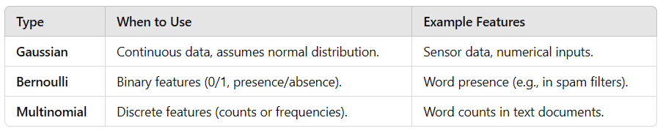

5. Why is Naive Bayes Powerful?
- Fast and Simple:
  - Easy to implement and computationally efficient.
- Handles Small Datasets:
  - Works well even with limited data.
- Robust with Irrelevant Features:
  - Because it calculates probabilities independently for each feature, irrelevant features don’t significantly impact performance.

6. Real-World Examples
- Spam Filters: Predict whether an email is spam or not.
  - Features: Words in the email.
  - Output: "Spam" or "Not Spam".
- Sentiment Analysis: Determine if a review is positive or negative.
  - Features: Words in the review.
  - Output: "Positive" or "Negative".
- Disease Diagnosis: Predict if a patient has a disease.
  - Features: Symptoms.
  - Output: "Has Disease" or "Doesn’t Have Disease".

7. When Not to Use Naive Bayes?
- Correlated Features: If features are highly dependent, the "naive" assumption fails.
  - Example: Predicting house price using size and number of rooms (which are correlated).
- Complex Decision Boundaries: If the data requires non-linear decision boundaries, Naive Bayes may not perform well.

8. Why Does It Work Despite the "Naive" Assumption?
Even when features are not truly independent:
- Naive Bayes calculates probabilities robustly by combining likelihoods.
- The model focuses on capturing the overall trend rather than fine-grained dependencies.

In Summary:
- Naive Bayes is a simple but powerful classification tool.
- It works well when:
  - Features are mostly independent.
  - The problem involves probabilities and straightforward patterns.
- Use it for tasks like text classification, spam detection, and medical diagnosis.

Gaussian Naive Bayes (GNB)

Gaussian Naive Bayes (GNB) is a classification algorithm that is based on Bayes' theorem with the assumption that features are continuous and normally distributed (Gaussian) within each class. To effectively use GNB, the following assumptions are made:

1. Conditional Independence Assumption
- Key Assumption: The features are conditionally independent given the class. This means that the presence or value of one feature does not influence or depend on another feature within the same class.
- Example: If you are classifying emails as spam or not spam based on features like word frequencies, the model assumes that the frequency of one word is independent of the frequency of another, given the class label.

2. Gaussian Distribution of Features
- Key Assumption: The features follow a Gaussian (normal) distribution within each class. For each class, the probability of a feature value is modeled as a normal distribution.
- Mathematical Representation:

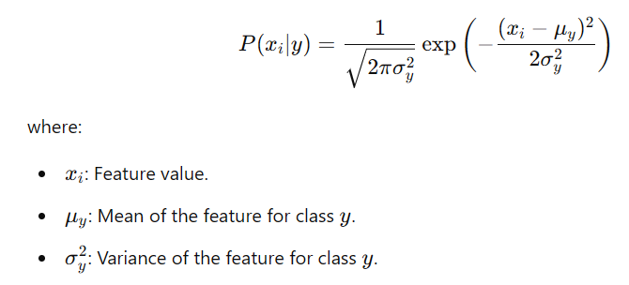

3. Homoscedasticity (Optional)
- GNB assumes that for a given class, the variance of each feature is constant. However, this assumption can be relaxed, as the model can still handle features with varying variances.

4. Non-Correlated Features
- Implicit in the conditional independence assumption, features should ideally not be highly correlated. If features are correlated, the independence assumption is violated, which can degrade performance.

5. Balanced Feature Relevance
- All features are assumed to contribute equally to the final classification. If certain features dominate others, preprocessing (e.g., feature scaling) may be necessary.

6. Applicability to Continuous Features
- Gaussian Naive Bayes is best suited for datasets where features are continuous and roughly Gaussian-distributed. For categorical features, other versions of Naive Bayes (e.g., Multinomial or Bernoulli Naive Bayes) are more appropriate.

Practical Considerations:
- Feature Scaling: GNB does not require explicit scaling (like normalization or standardization) since it calculates probabilities using mean and variance, which are scale-invariant for Gaussian distributions.
- Violation of Assumptions: In real-world data, these assumptions are rarely perfectly met. GNB can still perform well in many cases, particularly when conditional independence is approximately true.
- Handling Non-Gaussian Features: If features deviate significantly from a Gaussian distribution, preprocessing techniques such as transformation (e.g., log, square root) or outlier handling may improve performance.
By understanding these assumptions, you can decide whether Gaussian Naive Bayes is appropriate for your dataset or if additional preprocessing or an alternative method is needed.

Assumptions of Bernoulli Naive Bayes (BNB)
Bernoulli Naive Bayes is a classification algorithm particularly suited for binary/categorical data, such as text classification with presence/absence features. Its assumptions include:

1. Binary Features
- Key Assumption: Each feature is binary, representing the presence (1) or absence (0) of a feature.
- Example: In text classification, each feature might indicate whether a specific word is present in a document or not.

2. Conditional Independence
- Key Assumption: Features are conditionally independent given the class. This means the presence or absence of one feature does not affect the presence or absence of another, given the class label.

3. Relevance of Features to Class Labels
- Key Assumption: Each binary feature contributes independently to the probability of a class label. Features are assumed to be relevant to the classification task.

4. Suitability for Binary Data
- Bernoulli Naive Bayes is ideal for datasets with binary-valued features (0/1). For datasets with continuous or count-based features, this algorithm may not perform well unless data is transformed into binary format.

Laplace Smoothing (Additive Smoothing)
Laplace smoothing is a technique used in probabilistic models, including Naive Bayes, to handle cases where certain probabilities are zero due to missing observations in the training data.

Why Use Laplace Smoothing?
- When calculating probabilities P(xi∣y)P(x_i | y)P(xi​∣y) in Naive Bayes, if a particular feature xix_ixi​ is absent in all training samples for a specific class yyy, the probability becomes zero.
- This zero probability propagates through the product of probabilities in Bayes’ theorem, resulting in a zero likelihood for the entire class, which is undesirable.

How Laplace Smoothing Works
- Laplace smoothing adds a small constant α\alphaα (usually α=1\alpha = 1α=1) to each count to ensure no probability is zero.
- Smoothed Probability Formula:

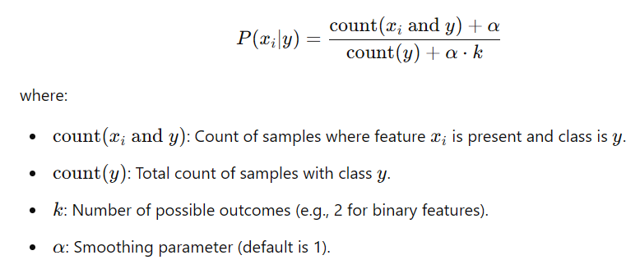

When to Use Laplace Smoothing
Laplace smoothing is useful in the following scenarios:
- Handling Missing Data:
  - If certain feature-class combinations are missing in the training data, Laplace smoothing prevents zero probabilities.
- Small Datasets:
  - In datasets with limited training samples, smoothing helps generalize probabilities by avoiding overfitting to observed data.
- Sparse Feature Spaces:
  - For problems like text classification with sparse vectors (e.g., bag-of-words), where many features (words) may not appear in all classes, smoothing ensures robust probability estimation.
- Binary or Discrete Features:
  - Particularly helpful for Bernoulli or Multinomial Naive Bayes, where features are binary or count-based.

Summary of Use Cases
- Use Bernoulli Naive Bayes when:
  - Features are binary (presence/absence).
  - You are working with text data represented by binary feature vectors, such as in spam detection or sentiment analysis.
- Apply Laplace Smoothing to:
  - Avoid zero probabilities in classification.
  - Improve model performance on sparse or small datasets.
These techniques ensure the model remains robust and reliable in a variety of real-world scenarios.

Assumptions of Multinomial Naive Bayes (MNB)
Multinomial Naive Bayes is commonly used for classification tasks where features represent counts or frequencies, such as text classification with a bag-of-words model. Its assumptions include:

1. Feature Representation as Counts or Frequencies
- Key Assumption: Features are discrete and represent the count or frequency of events (e.g., word occurrences in text).
- Example: In text classification, features might be the number of times each word appears in a document.

2. Conditional Independence
- Key Assumption: Features are conditionally independent given the class. This means the count of one feature is independent of another, given the class label.

3. Feature-Class Relevance
- Key Assumption: Each feature contributes independently to the probability of a class label. More frequently occurring features contribute more strongly to class probability.

4. Suitability for Count Data
- Multinomial Naive Bayes is designed for datasets where features are counts or non-negative integers. It assumes that higher counts correlate with higher importance in classification.

Laplace Smoothing in Multinomial Naive Bayes

Why Use Laplace Smoothing?
Laplace (or additive) smoothing is crucial in Multinomial Naive Bayes to handle missing counts and ensure the model does not assign zero probability to unseen feature-class combinations.
- In text classification, if a particular word (feature) does not appear in the training samples for a class, its probability for that class would be zero. This zero probability would make the entire class likelihood zero when using Bayes’ theorem.
- Laplace smoothing addresses this issue by adding a small constant α\alphaα to every count.

How Laplace Smoothing Works
- Adds α\alphaα (typically 1) to all feature counts in the likelihood estimation.
- Smoothed Probability Formula:

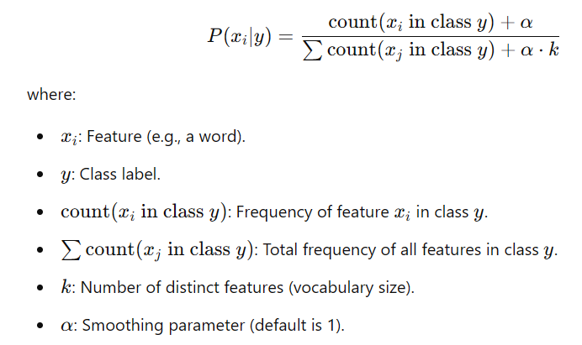

When to Use Laplace Smoothing
Laplace smoothing is particularly useful in Multinomial Naive Bayes in the following scenarios:
- Sparse Data:
  - When many features (e.g., words) have zero counts for certain classes in the training data, smoothing avoids zero probabilities.
  - Example: A word appearing in test data but not in the training data for a specific class.
- Small Datasets:
  - Ensures the model generalizes better when training data is limited, and unseen feature-class combinations are likely.
- Text Data:
  - Essential for text classification tasks using bag-of-words or term frequency representations.
- Non-Zero Probabilities:
  - Ensures all features have a non-zero probability for all classes, making the model robust to unseen data.

Key Differences from Bernoulli Naive Bayes
- Data Representation:
  - Multinomial Naive Bayes uses counts (frequencies), whereas Bernoulli Naive Bayes uses binary indicators (presence/absence).
- Laplace Smoothing Purpose:
  - In Multinomial Naive Bayes, smoothing is applied to counts for probability estimation.
  - In Bernoulli Naive Bayes, smoothing is applied to handle absence (0) probabilities.

Summary of Use Cases
- Use Multinomial Naive Bayes when:
  - Features are counts or frequencies (e.g., bag-of-words, term frequency).
  - You are working on text classification, sentiment analysis, or spam detection with non-binary features.
- Apply Laplace Smoothing to:
  - Avoid zero probabilities in classification.
  - Handle sparse datasets or unseen feature-class combinations.
By leveraging these assumptions and applying Laplace smoothing appropriately, Multinomial Naive Bayes becomes a powerful and robust algorithm for text and count-based classification tasks.

1. Bernoulli Naive Bayes Example

Scenario:
You are classifying emails as Spam or Not Spam based on the presence or absence of specific words in the email.

Data:
Email | Contains "Buy" | Contains "Offer" | Contains "Discount" | Class
1 | 1 | 1 | 1 | Spam
2 | 1 | 0 | 1 | Spam
3 | 0 | 0 | 0 | Not Spam
4 | 0 | 1 | 0 | Not Spam
- Features: Binary (1 = word present, 0 = word absent).
- Class Labels: "Spam" or "Not Spam."

Probability Calculation:
For a new email:
Contains "Buy" = 1, Contains "Offer" = 1, Contains "Discount" = 0

Using Bernoulli Naive Bayes:
- Calculate probabilities for Spam and Not Spam:
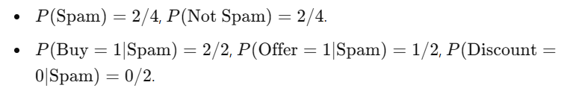
- Apply Laplace Smoothing (if needed) to avoid zero probabilities:

2. Multinomial Naive Bayes Example

Scenario:
You are classifying documents as Positive or Negative based on the word frequency in a bag-of-words model.

Data:
Document | "Good" | "Bad" | "Great" | "Terrible" | Class
1 | 2 | 0 | 1 | 0 | Positive
2 | 1 | 0 | 1 | 0 | Positive
3 | 0 | 2 | 0 | 1 | Negative
4 | 0 | 1 | 0 | 2 | Negative
- Features: Word counts (e.g., "Good" appears 2 times in Document 1).
- Class Labels: "Positive" or "Negative."

Probability Calculation:
For a new document:
"Good" = 1, "Bad" = 0, "Great" = 1, "Terrible" = 0

Using Multinomial Naive Bayes:
- Calculate probabilities for each word given a class:
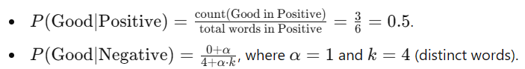
- Compute class probabilities:
- Calculate overall probabilities using Bayes' theorem: Multiply P(Good), P(Great), etc., for each class and normalize.

3. Laplace Smoothing Example

Without Smoothing:
Suppose you have a dataset:
- Class A: 3 samples, word "Fantastic" appears 2 times.
- Class B: 3 samples, word "Fantastic" appears 0 times.
For a new sample containing "Fantastic":
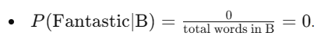
This leads to zero likelihood for Class B.

With Laplace Smoothing:
Add α=1 to all counts:
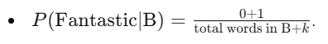
Smoothed probabilities avoid zero probabilities, ensuring the model doesn't completely ignore a class.

Summary
- Bernoulli Naive Bayes: Use binary features (presence/absence).
- Multinomial Naive Bayes: Use count features (frequencies).
- Laplace Smoothing: Prevent zero probabilities for unseen features/classes.

1. Bernoulli Naive Bayes

Code:
X_binary = (X > 0).astype(int)

Explanation:
- Why Convert to Binary?
  - Bernoulli Naive Bayes works with binary data where each feature indicates the presence (1) or absence (0) of a characteristic.
  - The dataset X may contain continuous or count-based values, which do not fit Bernoulli Naive Bayes' assumption of binary features.
  - The transformation (X > 0).astype(int) converts all positive values to 1 (presence) and all zero or negative values to 0 (absence), ensuring that the features comply with Bernoulli Naive Bayes' requirements.

2. Multinomial Naive Bayes

Code:
scaler_minmax = MinMaxScaler()
X_minmax = scaler_minmax.fit_transform(X)

Explanation:
- Why Use MinMaxScaler?
  - Multinomial Naive Bayes assumes that features represent counts or frequencies. If the dataset contains features on widely different scales (e.g., one feature ranges from 0 to 1 while another ranges from 0 to 1000), it might skew the model.
  - MinMaxScaler scales all feature values to a range of [0, 1], ensuring the features are proportional and normalized while preserving their relative differences.
  - This step makes the data suitable for Multinomial Naive Bayes, which expects non-negative values and often benefits from normalized ranges.

3. Gaussian Naive Bayes

Code:
scaler = StandardScaler()
X_scaled = scaler.fit_transform(X)

Explanation:
- Why Use StandardScaler?
  - Gaussian Naive Bayes assumes that features follow a Gaussian (normal) distribution. StandardScaler standardizes the dataset by centering the mean at 0 and scaling the variance to 1.
  - Standardizing ensures that each feature's distribution aligns better with the Gaussian assumption, improving the algorithm's performance.
  - Without standardization, features with larger scales might dominate the calculation of probabilities, violating the algorithm's assumptions.

Why Preprocessing Differs for Each Naive Bayes Variant?

1. Bernoulli Naive Bayes:
- Works with binary data (presence/absence of features).
- Converting features to binary ensures compliance with the algorithm's assumptions.

2. Multinomial Naive Bayes:
- Works with count or frequency data.
- Features must be non-negative, and normalization (e.g., MinMaxScaler) helps scale the counts to a uniform range.

3. Gaussian Naive Bayes:
- Works with continuous data.
- Standardizing ensures features approximate a Gaussian distribution, aligning with the algorithm's assumptions.

Summary of Transformations:
Algorithm | Data Assumption | Preprocessing Step
Bernoulli Naive Bayes | Binary (0/1) | Convert features to binary: (X > 0).astype(int)
Multinomial Naive Bayes | Non-negative counts/frequencies | Normalize using MinMaxScaler
Gaussian Naive Bayes | Continuous, Gaussian-like | Standardize using StandardScaler
By applying the correct preprocessing for each algorithm, the notebook ensures that the features align with the assumptions of the corresponding Naive Bayes variant, leading to better classification performance.

